Write an application that performs few operations on a sentence. Implement the application by defining the functions given below. You can define a fixed size character array in main function to hold the sentence.
Requirement Tag | Requirement Description | Comments
STR/01 | Write a function to accept a sentence from the user. | Hint: Use fgets function
STR/02 | Write a function which accepts the sentence and prints one word in a line. A word is a sequence of non-whitespace characters | The function returns the  number of words
STR/03 | Write a function to print the longest word in the sentence (assume all words are of different length). | The function returns the  size of the longest word.
STR/04 | Write a function to prompt and read a search sub string, search for the first word containing this substring in input sentence, remove the word and display the sentence after update. | Hint: Use strstr() to search.
STR/05 | Print all words in one line without printing any whitespace
STR/06 | Write a function to replace all the whitespaces with "!". The  function returns the number of replacement done. | int replacews(mystr,  myreplacement)

STR/01 :
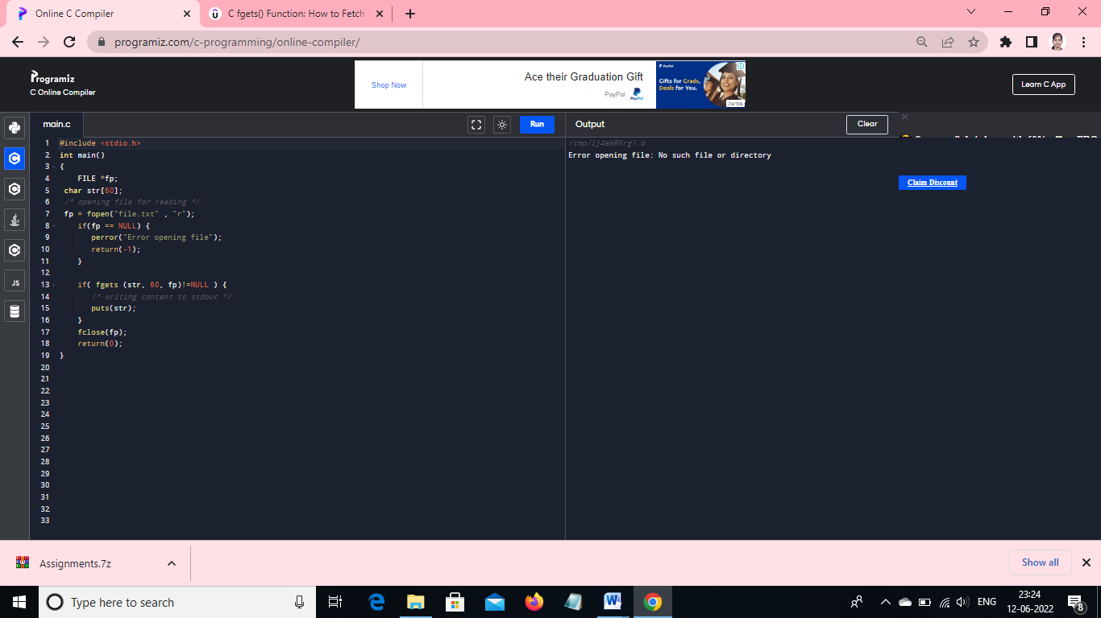

STR/02:
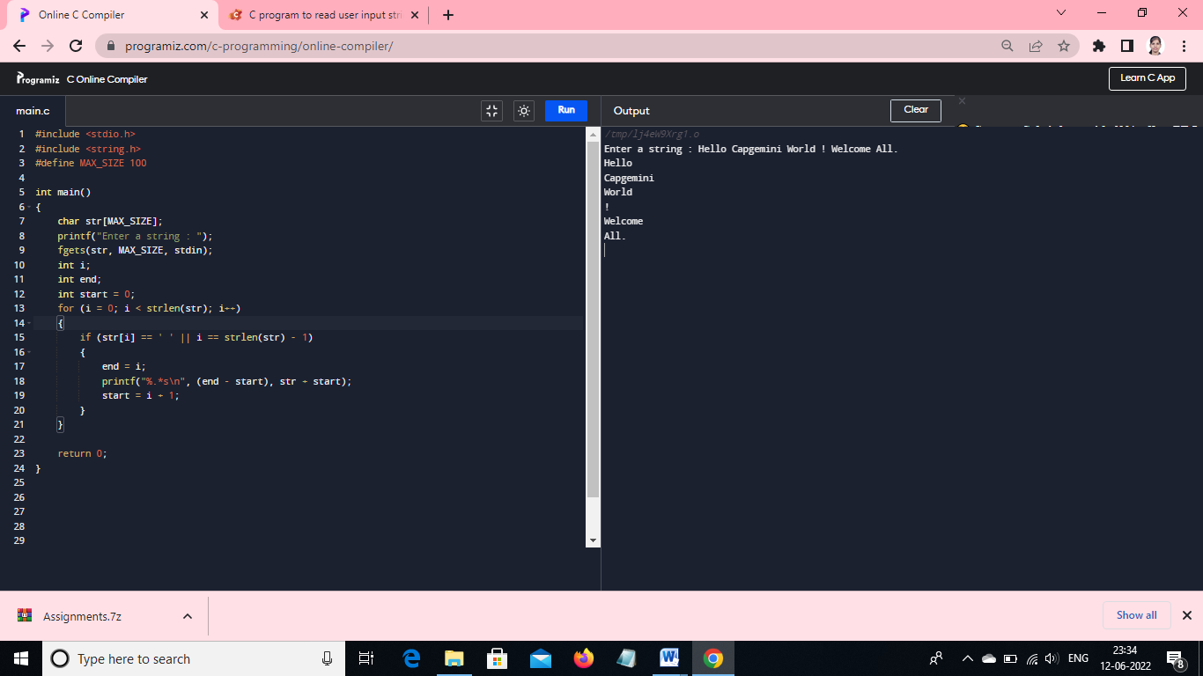

STR/03:
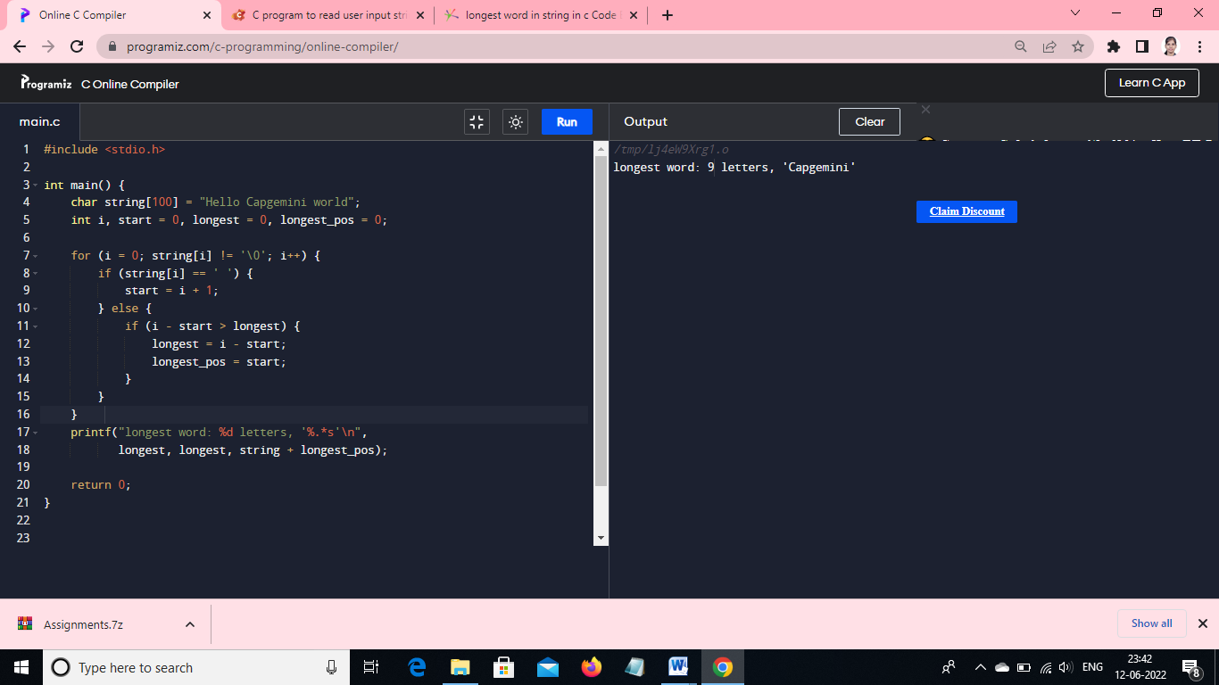

STR/04:

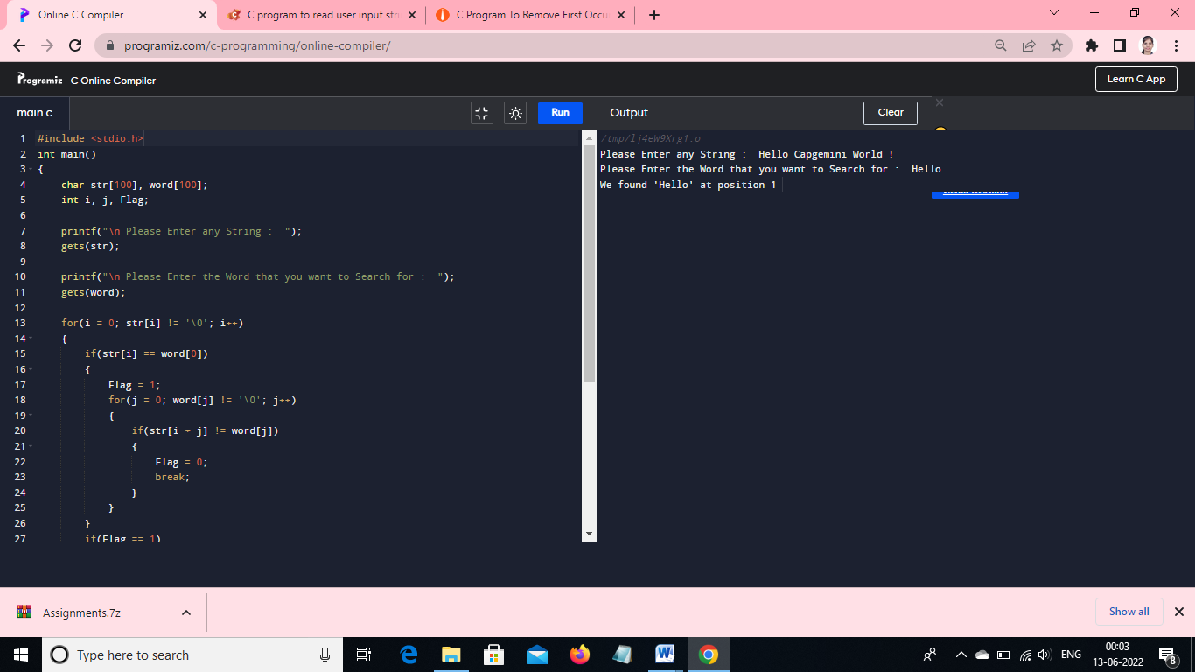
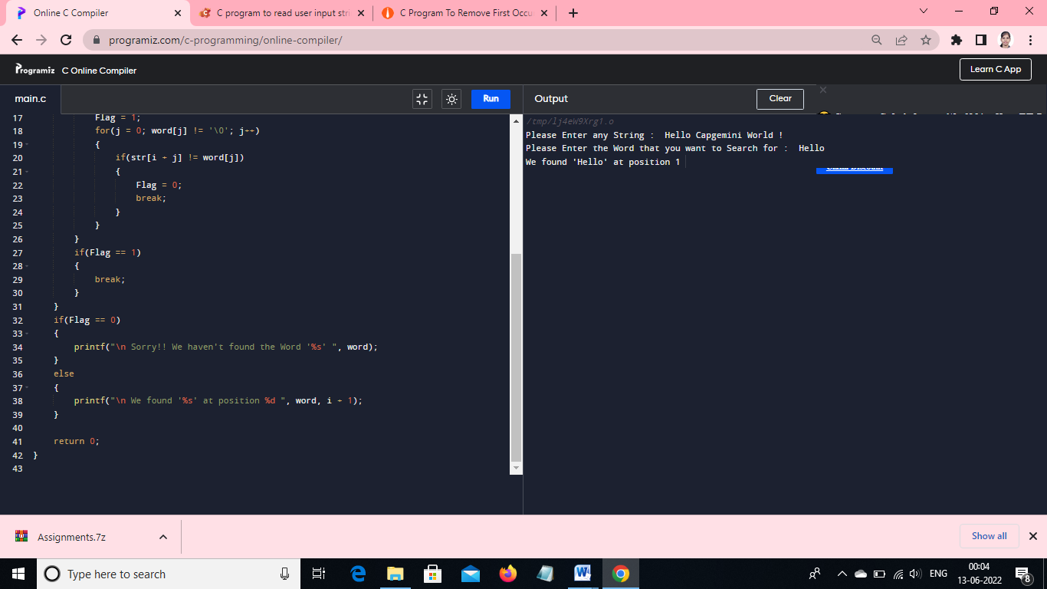

STR 04 : To remove the first word and display the sentence after update

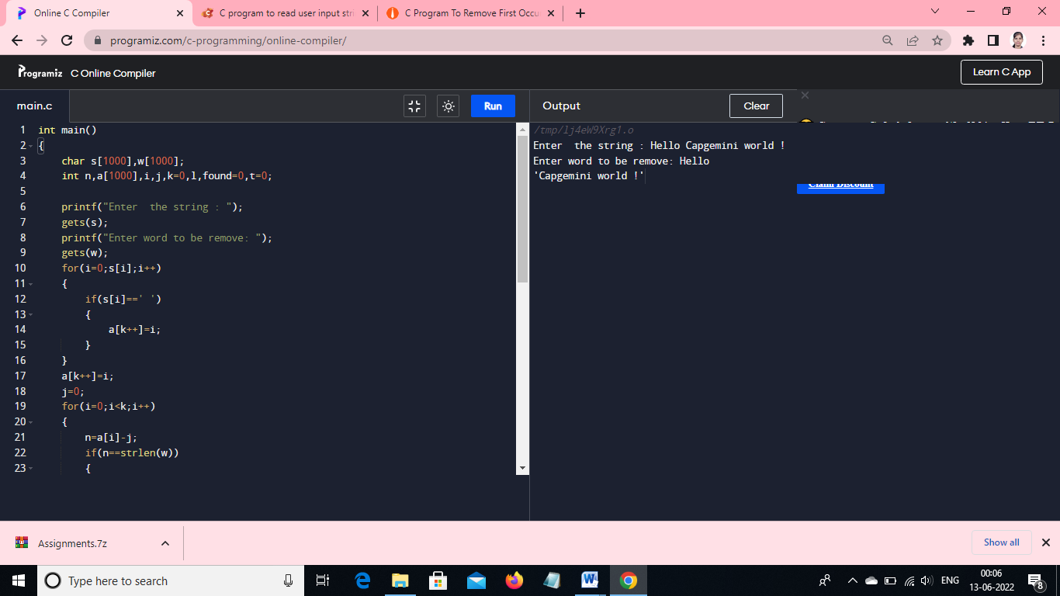
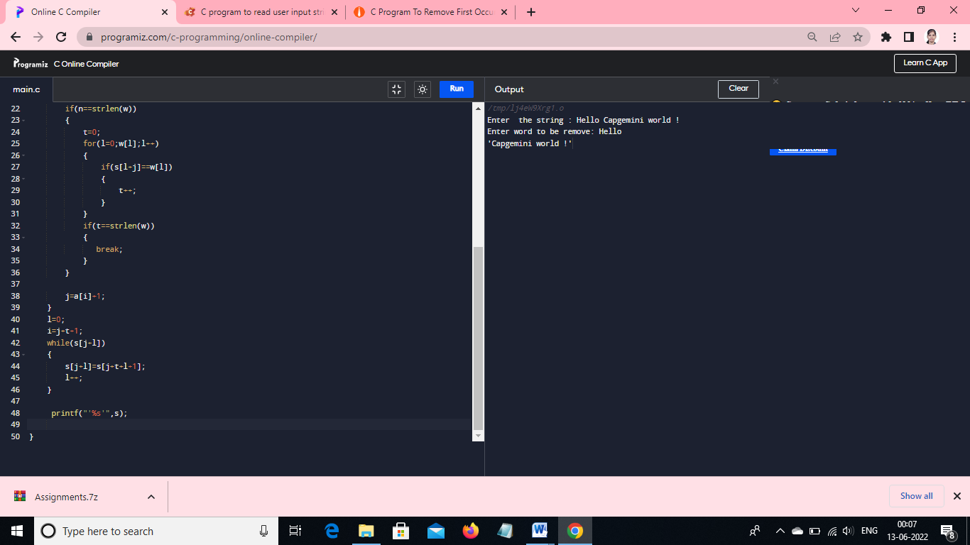

STR 05:

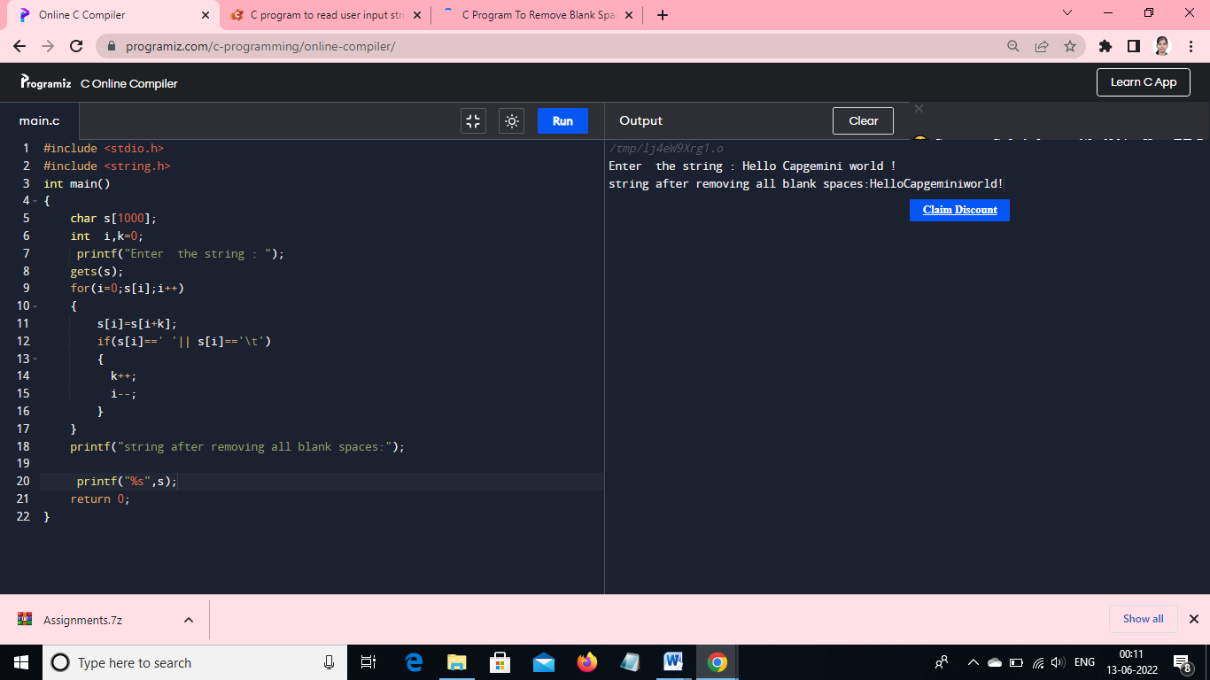

STR 06

